Supplement

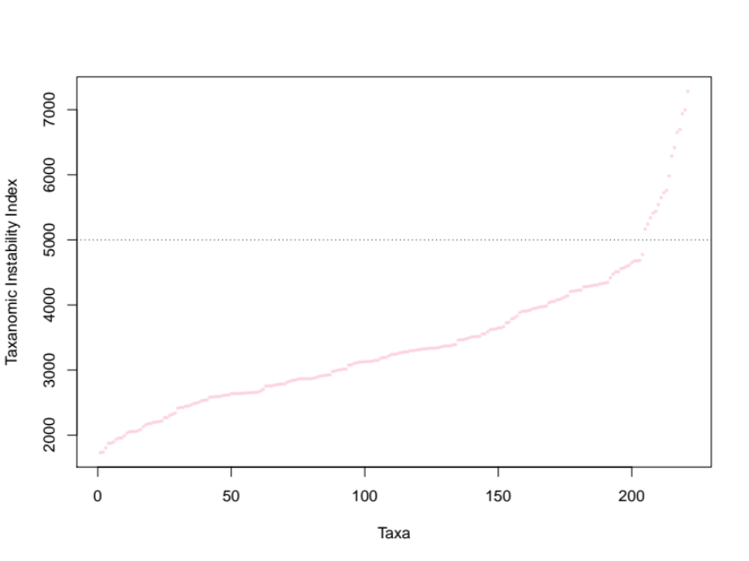
Supplemental Figure 1. Taxonomic instability indices based on 100 maximum likelihood tree inferences. The dashed line shows the chosen cutoff, an index of 5000. Most taxa, 92%, fall below this while above this value increases quickly.

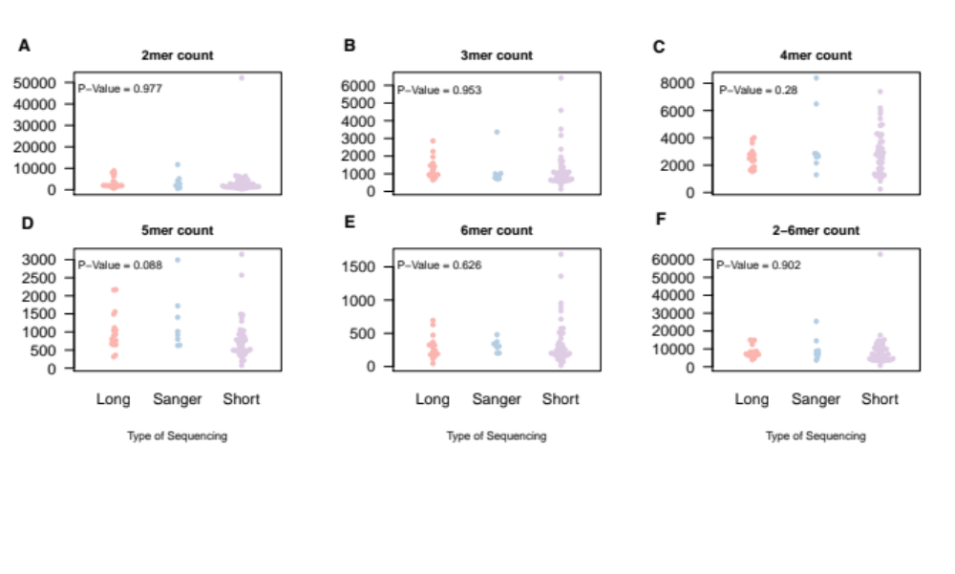
Supplemental Figure 2. Microsatellite inference and the type of sequencing (short, Sanger, long) using vertebrate genome dataset. This shows the relationship between inference of 2-mer, 3-mer, 4-mer, 5-mer, 6-mer, and total (2-6mer) microsatellite count and the types of sequencing with phylogenetic ANOVA values in the upper left hand for each type.

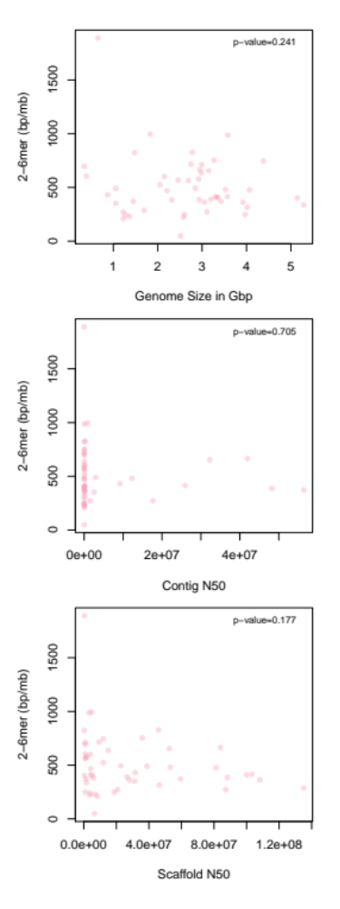
Supplemental Figure 3. Measures of the quality of genomes (scaffold N50, contig N50, and genome size) and microsatellite inference. Linear model p-values are indicated in the upper right-hand corner for each of the analyses.

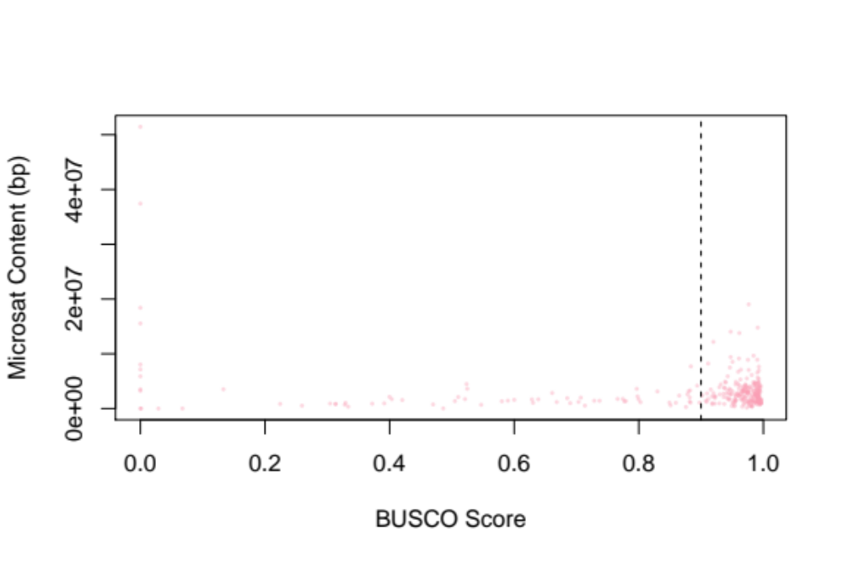
Supplemental Figure 4. BUSCO scores and microsatellite content (bp/Mbp). The vertical black line indicates the threshold of 90 that was required for inclusion in our study. There were 83 genomes that were discarded based on this threshold.

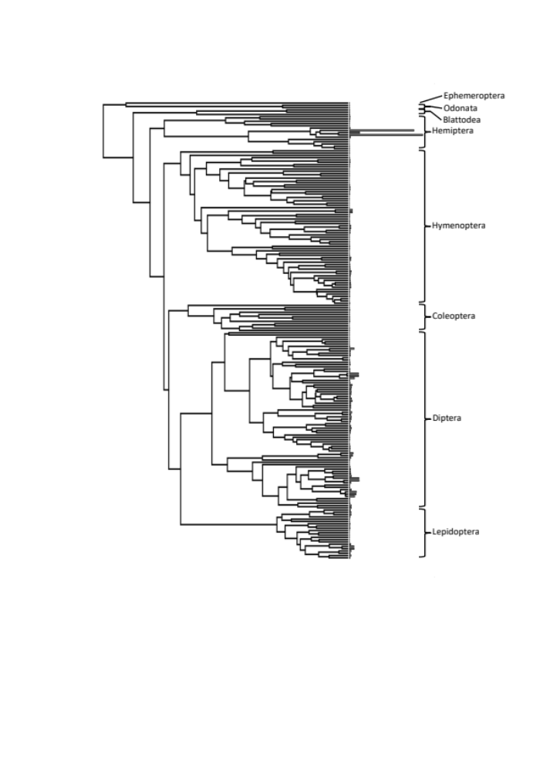
Supplemental Figure 5. Tip rates for microsatellite evolution across each of the taxa in our phylogeny. The bars at the end of each tip represents the absolute value of the microsatellite evolution tip rates for each taxa.

Supplemental Table 1. All genomes and accession numbers for the 303 insect species that are included in the analyses. Genome assemblies were downloaded from NCBI (https://www.ncbi.nlm.nih.gov), ENSEMBL (https://useast.ensembl.org/index.html), and Baylor HGC (https://www.hgsc.bcm.edu/arthropods/i5k).

Order | Species | Accession | Notes
Lepidoptera | Achalarus lyciades | MOOZ01000001.1
Hymenoptera | Acromyrmex echinatior | NW_011623521.1
Hemiptera | Acyrthosiphon pisum | GL349630
Diptera | Aedes aegypti | GCF_002204515.2_AaegL5.0
Diptera | Aedes albopictus | NW_017855997.1
Coleoptera | Aethina tumida | NW_017852934
Coleoptera | Agrilus planipennis | NW_017259594
Coleoptera | Aleochara bilineata | NBZA01000001
Plecoptera | Amphinemura sulcicollis | LVVV01000001
Lepidoptera | Amyelois transitella | NW_013534156
Diptera | Anopheles alnimanus | CM008152
Diptera | Anopheles aquasalis | NJHH01000001
Diptera | Anopheles arabiensis | KB704125
Diptera | Anopheles atroparvus | KI421882
Diptera | Anopheles christyi | KB673756
Diptera | Anopheles coluzzii | EQ097730
Diptera | Anopheles cracens | KZ067108
Diptera | Anopheles culicifacies | KI422464
Diptera | Anopheles darlingi | ADMH00000000
Diptera | Anopheles dirus | KB672490
Diptera | Anopheles epiroticus | KB669613
Diptera | Anopheles farauti | KI915040
Diptera | Anopheles funestus | KB668221
Diptera | Anopheles gambiae | AAAB00000000
Diptera | Anopheles koliensis | JXXB01000001
Diptera | Anopheles maculatus | KZ061539
Diptera | Anopheles melas | KI919284
Diptera | Anopheles merus | KI915156
Diptera | Anopheles minimus | KB663610
Diptera | Anopheles nili | ATLZ01000001
Diptera | Anopheles punctulatus | JXXA01000001
Diptera | Anopheles quadriannulatus | KB665398
Diptera | Anopheles sinensis | KL639024
Diptera | Anopheles stephensi | KE388890
Coleoptera | Anoplophora glabripennis | KB933500
Lepidoptera | Antheraea yamamai | PRJNA383008 | GigaDB Database
Hymenoptera | Aphaenogaster ashmeadi | NJRQ01000001
Hymenoptera | Aphaenogaster floridana | NJRP01000001
Hymenoptera | Aphaenogaster fulva | NJRO01000001
Hymenoptera | Aphaenogaster miamiana | NJRN01000001
Hymenoptera | Aphaenogaster picea | NJRM01000001
Hymenoptera | Aphaenogaster rudis | NJRL01000001
Hymenoptera | Apis cerana | NW_016017455
Hymenoptera | Apis dorsata | NW_006263304
Hymenoptera | Apis florea | NW_003789104
Hymenoptera | Apis mellifera | NC_037638 - NC_037653 | 1 dna:chromosome_group chromosome_group:Amel_4.5:1:1:29893408:1 REF
Hymenoptera | Athalia rosae | NW_012161901
Hymenoptera | Atta cephalotes | GCF_000143395 | >scaffold00001 dna:supercontig supercontig:Attacep1.0:scaffold00001:1:15679321:1 REF
Hymenoptera | Atta colombica | NW_017258044
Diptera | Bactrocera dorsalis | NW_011869236
Diptera | Bactrocera latifrons | NW_017534406
Diptera | Bactrocera oleae | NW_013581209
Diptera | Bactrocera tryoni | JHQJ01000001
Ephemeroptera | Baetis rhodani | LVVX01000001
Diptera | Belgica antarctica | JPYR01000001
Hemiptera | Bemisia tabaci | NW_017547088
Lepidoptera | Bicyclus anynana | NW_019862748
Blattodea | Blattella germanica | PYGN01000001
Hymenoptera | Bombus impatiens | JH157811
Hymenoptera | Bombus terrestris | CM001169 - CM001186 | >B01 dna:chromosome_group chromosome_group:Bter_1.0:B01:1:17153651:1 REF
Lepidoptera | Bombyx huttoni | ASCI01000001
Lepidoptera | Bombyx mori | GCF_000151625 | >scaf1 dna:supercontig supercontig:ASM15162v1:scaf1:1:16203812:1 REF
Lepidoptera | Calephelis nemesis | NJDD01000001
Lepidoptera | Calephelis virginiensis | NJDC01000001
Diptera | Calliphora vicina | JXOT01000001
Odonata | Calopteryx splendens | LYUA01000001
Lepidoptera | Calycopis cecrops | LUGF01000001
Hymenoptera | Camponotus floridanus | NW_020229214
Diplura | Catajapyx aquilonaris | KZ537955
Hymenoptera | Cecidostiba fungosa | UCOJ01000001
Hymenoptera | Cecidostiba semifascia | UCQR01000001
Isoptera | CEME01 microsat.txt | CEME01000001
Hymenoptera | Cephus cinctus | NW_014332639
Hymenoptera | Ceratina calcarata | NW_017130860
Diptera | Ceratitis capitata | NW_019376232
Hymenoptera | Ceratosolen solmsi | NW_011948412
Diptera | Chaoborus trivitattus | JXOU01000001
Lepidoptera | Chilo suppressalis | ANCD01000001
Diptera | Chironomus riparius | JXPV01000001
Diptera | Chironomus tentans | HG428765
Hemiptera | Cimex hemipterus | LRFB01000001
Hemiptera | Cimex lectularius | NW_019942502
Diptera | Cirrula hians | JXOS01000001
Phasmatodea | Clitarchus hookeri | NQII01000001
Diptera | Clogmia albipunctata | JXOV01000001
Diptera | Clunio marinus | CVRI01000001
Diptera | Coboldia fuscipes | JXOR01001678
Diptera | Condylostylus patibulatus | JXOW01000001
Hymenoptera | Copidosoma floridanum | NW_019379452
Hymenoptera | Cotesia vestalis | JZSA01000001
Blattodea | Cryptotermes secundus | NW_019718022
Diptera | Culex quinquefasciatus | NZ_AAWU00000000.1 | >supercont3.1 dna:supercontig supercontig:CpipJ2:supercont3.1:1:3873040:1 REF
Diptera | Culicoides sonorensis | OGVF02000001
Hymenoptera | Cyphomyrmex costatus | NW_017265214
Hemiptera | Dactylopius coccus | JMCM01001127
Lepidoptera | Danaus plexippus | DPSCF300001
Coleoptera | Dendroctonus ponderosae | APGK00000000.1 9 (INSDC) | >Seq_1103023 dna:supercontig supercontig:DendPond_male_1.0:Seq_1103023:1:4163268:1 REF
Coleoptera | Diabrotica virgifera | KZ688668
Hymenoptera | Diachasma alloeum | NW_015144998
Hemiptera | Diaphorina citri | NW_007377440
Hymenoptera | Dinoponera quadriceps | NW_014554123
Hymenoptera | Diuraphis noxia | NW_015368242
Diptera | Drosophila albomicans | JH838198
Diptera | Drosophila americana | CWKB01000001
Diptera | Drosophila ananassae | QMES00000000.2 (GenBank) | >scaffold_13340 dna:supercontig supercontig:dana_caf1:scaffold_13340:1:23697760:1 REF
Diptera | Drosophila arizonae | NW_017127682
Diptera | Drosophila biarmipes | NW_016028565
Diptera | Drosophila bipectinata | NW_016083910
Diptera | Drosophila busckii | NC_030802
Diptera | Drosophila elegans | NW_016078481
Diptera | Drosophila erecta | QMER00000000.2 (GenBank) | >scaffold_4929 dna:supercontig supercontig:dere_caf1:scaffold_4929:1:26641161:1 REF
Diptera | Drosophila eugracilis | NW_016073535
Diptera | Drosophila ficusphila | NW_016067781
Diptera | Drosophila grimshawi | GCF_000005155.2 | >scaffold_15110 dna:supercontig supercontig:dgri_caf1:scaffold_15110:1:24565398:1 REF
Diptera | Drosophila hydei | NW_019378586
Diptera | Drosophila kikkawai | NW_016062640
Diptera | Drosophila melanogaster | GCF_000001625.3 | >2L dna:chromosome chromosome:BDGP6:2L:1:23513712:1 REF
Diptera | Drosophila miranda | NC_030302.1
Diptera | Drosophila mojavensis | GCF_000005175.2 | >scaffold_6540 dna:supercontig supercontig:dmoj_caf1:scaffold_6540:1:34148556:1 REF
Diptera | Drosophila montana | LUVX01000001
Diptera | Drosophila nasuta | LYTC01000001
Diptera | Drosophila navojoa | NW_017181428
Diptera | Drosophila novamexicana | QMEP01000001
Diptera | Drosophila obscura | NW_019152098
Diptera | Drosophila persimilis | GCF_003286085.1 | >scaffold_0 dna:supercontig supercontig:dper_caf1:scaffold_0:1:11822988:1 REF
Diptera | Drosophila pseudoobscura | GCF_000001765.3 | >2 dna:chromosome chromosome:Dpse_3.0:2:1:30819483:1 REF
Diptera | Drosophila rhopaloa | NW_016039821
Diptera | Drosophila sechellia | GCF_004382195.1 | >scaffold_0 dna:supercontig supercontig:dsec_caf1:scaffold_0:1:21120651:1 REF
Diptera | Drosophila serrata | NW_018366212
Diptera | Drosophila simulans | GCF_000754195.2 | >2L dna:chromosome chromosome:ASM75419v3:2L:1:23539531:1 REF
Diptera | Drosophila subobscura | NGKO01001875
Diptera | Drosophila suzukii | NW_016019885
Diptera | Drosophila takahashii | NW_016034088
Diptera | Drosophila virilis | GCF_003285735.1 | >scaffold_13049 dna:supercontig supercontig:dvir_caf1:scaffold_13049:1:25233164:1 REF
Diptera | Drosophila willistoni | GCF_000005925.1 | >scf2_1100000004943 dna:supercontig supercontig:dwil_caf1:scf2_1100000004943:1:16660200:1 REF
Diptera | Drosophila yakuba | GCF_000005975.2 | >2L dna:chromosome chromosome:dyak_caf1:2L:1:22324452:1 REF
Phasmatodea | Dryococelus australis | NKXL01000001
Hymenoptera | Dufourea novaeangliae | NW_015373878
Ephemeroptera | Ephemera danica | KZ497563
Diptera | Ephydra gracilis | JXPQ01000001
Diptera | Eristalis dimidiata | JXPC01000001
Hymenoptera | Eufriesea mexicana | NW_016907855
Hymenoptera | Euglossa Dilemma | NIJG01000001
Hymenoptera | Eupelmus annulatus | UDEW01000001
Hymenoptera | Eupelmus urozonus | UELX01000001
Diptera | Eutreta diana | JXPB01000001
Hemiptera | Ferrisia virgata | FIZR01000001
Diptera | Fopius arisanus | NW_011887740
Thysanoptera | Frankliniella occidentalis | KZ555990
Lepidoptera | Galleria mellonella | NTHM01000001
Hemiptera | Gerris buenoi | KZ651037
Diptera | Glossina austeni | KK502400
Diptera | Glossina brevipalpis | KK351011
Diptera | Glossina fuscipes | GCA_000671735.1 | >Scaffold0 dna:supercontig supercontig:GfusI1:Scaffold0:1:3329503:1
Diptera | Glossina morsitans | GCA_001014515.1 | >scf7180000652170 dna:supercontig supercontig:GmorY1:scf7180000652170:1:25362821:1
Diptera | Glossina pallidipes | GCA_000688715.1 | >Scaffold0 dna:supercontig supercontig:GpalI1:Scaffold0:1:5836930:1
Diptera | Glossina palpalis | KN796171
Hymenoptera | Goniozus legneri | NCVS01000001
Hymenoptera | Habropoda laboriosa | NW_017100116
Diptera | Haematobia irritans | PGFW01000001
Hemiptera | Halyomorpha halys | NW_020110170
Hymenoptera | Harpergnathos saltator | NW_020229871
Lepidoptera | Heliconius cydno | FAPN01000001
Lepidoptera | Heliconius elevatus | FAPS01000001
Lepidoptera | Heliconius ethilla | FAPJ01000001
Lepidoptera | Heliconius hecale | FAPG01000001
Lepidoptera | Heliconius hecuba | FAQH01000001
Lepidoptera | Heliconius heurippa | FAPY01000001
Lepidoptera | Heliconius hierax | FAQL01000001
Lepidoptera | Heliconius ismenius | FAPP01000001
Lepidoptera | Heliconius melpomene | HE671591
Lepidoptera | Heliconius numata | FASQ01000001
Lepidoptera | Heliconius pachinus | FASS01000001
Lepidoptera | Heliconius pardalinus | FASU01000001
Lepidoptera | Heliconius timareta | FAUB01000001
Lepidoptera | Heliconius wallacei | FAUM01000001
Lepidoptera | Heliconius xanthocles | FAUE01000001
Lepidoptera | Helicoverpa armigera | NW_018395390
Lepidoptera | Helicoverpa punctigera | Hpuns12202012 | Accessed from i5k project
Lepidoptera | Helicoverpa zea | KZ116068
Lepidoptera | Heliothis virescens | NWSH01000001
Diptera | Hermetia illucens | JXPW01000001
Diptera | Holcocephala fusca | JXPE01000001
Hemiptera | Homalodisca vitripennis | KZ826510
Coleoptera | Hypothenemus hampei | LBGY01000001
Plecoptera | Isoperla grammatica | LVVW010000001
Lepidoptera | Laparus doris | FAQD01000001
Hymenoptera | Lasioglossum albipes | ANOB01000001
Hymenoptera | Lasius niger | LBMM01000001
Orthoptera | Laupala kohalensis | NNCF01000001
Plecoptera | Lednia tumana | QKMV01000001
Hymenoptera | Lepidotrigona ventralis | NIPQ01000001
Lepidoptera | Leptidea sinapsis | FZQP01000001
Coleoptera | Leptinotarsa decemlineata | NW_019289415
Hymenoptera | Leptopilina boulardi | PQAT01000001
Hymenoptera | Leptopilina clavipes | JUFY01000001
Lepidoptera | Lerema accius | LGAG01000001
Odonata | Libellula fulva | GCA_000376725.2
Trichoptera | Limnephilus lunatus | KZ319399
Hymenoptera | Linepithema hunile | NW_012157838
Diptera | Liriomyza trifolii | JXHJ01000001
Orthoptera | Locusta migratoria | AVCP010000001
Diptera | Lucilia cuprina | JRES01001160 | ref
Diptera | Lucilia sericata | JXPF01000001
Diptera | Lutzomyia longipalpis | JH689321
Archaeognatha | Machilis hrabei | GCA_003456935.1
Hemiptera | Maconellicoccus hirsutus | FIZS01000001
Hymenoptera | Macrocentrus cingulum | MVJL01000001
Lepidoptera | Mamestra configurata | NDFZ01000001
Lepidoptera | Manduca sexta | JH668279 | ref
Diptera | Mayetiola destructor | GL501517 | ref
Phasmatodea | Medauroidea extradentata | PNEQ01000001
Hymenoptera | Megachile rotundata | NW_003797049
Diptera | Megaselia abdita | JXPG01000001
Diptera | Megaselia scalaris | GCA_000341915.2 | >scaffold9042 dna:scaffold scaffold:Msca1:scaffold9042:1:114435:1 REF
Hymenoptera | Megastigmus dorsalis | UELU01000001
Hymenoptera | Megastigmus stigmatizans | UELV01000001
Hemiptera | Melanaphis sacchari | NW_020270366
Hymenoptera | Melipona quadrifasciata | KQ435686
Lepidoptera | Melitaea cinxia | GCA_000716385.1 | >scaffold1689 dna:scaffold scaffold:MelCinx1.0:scaffold1689:1:668473:1 REF
Strepsiptera | Mengenill moldrzyki | AGDA01000001
Hymenoptera | Microplitis demolitor | NW_014463221
Diptera | Mochlonyx cinctipes | JXPH01000001
Hymenoptera | Monomorium pharaonis | NW_012205351
Diptera | Musca domestica | NW_004754939
Hemiptera | Myzus persicae | NW_019100468
Hymenoptera | Nasonia giraulti | GL273804
Hymenoptera | Nasonia longicornis | GL277950
Hymenoptera | Nasonia vitripennis | GCF_009193385.2 | ref>1 dna:chromosome chromosome:Nvit_2.1:1:1:33571687:1 REF
Diptera | Neobellieria bullata | JXPI01000001
Hymenoptera | Neodiprion lecontei | NW_015380904
Lepidoptera | Neruda aoede | FAPZ01000001
Coleoptera | Nicrophorus vespilloides | NW_017095466
Hemiptera | Nilaparvata lugens | NW_019105540
Hemiptera | Oncopeltus fasciatus | KZ806866
Coleoptera | Onthophagus taurus | NW_019280316
Hymenoptera | Ooceraea biroi | NW_011924876
Lepidoptera | Operophtera brumata | JTDY01000001
Hymenoptera | Ormyrus nitidulus | UCOL01000001
Hymenoptera | Ormyrus pomaceus | UCOM01000001
Hymenoptera | Orussus abietinus | NW_019394231
Coleoptera | Oryctes borbonicus | LJIG01000001
Hemiptera | Pachypsylla venusta | KZ545295
Lepidoptera | Papilio glaucus | JWHW01000001
Lepidoptera | Papilio machaon | NW_014478584
Lepidoptera | Papilio memnon | BDMF01000001
Lepidoptera | Papilio polytes | NW_013524711
Lepidoptera | Papilio xuthus | NW_013528584
Hemiptera | Paracoccus marginatus | FIZT01000001
Diptera | Paykullia maculata | NDXZ01000001
Pthiraptera | Pediculus humanus | DS235882
Blatoodea | Periplaneta americana | PGRX01000001
Hemiptera | Philaenus spumarius | MPAX010000001
Diptera | Phlebotomus papatasi | JH660948
Lepidoptera | Phoebis sennae | LQNK01000631
Diptera | Phormia regina | MINK01000001
Diptera | Phortica variegata | JXPM01000001
Lepidoptera | Pieris rapae | NW_019093120
Hemiptera | Piezodorus guildinii | JTEQ01000001
Lepidoptera | Plodia interpunctella | LT849405
Lepidoptera | Plutella xylostella | NW_011952010
Hymenoptera | Pogomyrmex barbatus | NW_011929472
Coleoptera | Pogonus chalceus | CM008230
Hymenoptera | Polistes canadensis | NW_014569547
Hymenoptera | Polistes dominula | NW_015148970
Coleoptera | Priacma serrata | AGRH01000001
Diptera | Proctacanthus coquilletti | MNCL01000001
Hemiptera | Pseudococcus longispinus | FIZU01000001
Hymenoptera | Pseudomyrmex gracilis | NW_018020584
Diptera | Rhagoletis zephyria | NW_016157085
Hemiptera | Rhodnius prolixus | KQ034056
Diptera | Scaptodrosophila lebanonesis | QMEN01000001
Hemiptera | Schizaphis graminum | QEWZ01000001
Hemiptera | Sipha flava | NW_020271713
Coleoptera | Sitophilus oryzae | PPTJ01000001
Hymenoptera | Solenopsis invicta | GCF_000188075.2 | >Si_gnG.scaffold02694 dna:supercontig supercontig:Si_gnG:Si_gnG.scaffold02694:1:6355204:1 REF
Diptera | Sphyracephala brevicornis | JXPL01000001
Lepidoptera | Spodoptera frugiperda | NJHR01000001
Lepidoptera | Spodoptera litura | NC_036187
Diptera | Stomoxys calcitrans | NW_013171869
Hymenoptera | Synergus umbraculus | UCOK01000001
Diptera | Teleopsis dalmanni | NLCU01024205
Hymenoptera | Temnothorax curvispinosus | NW_020209781
Diptera | Tephritis californica | JXPN01000001
Diptera | Themira minor | JXPZ01000001
Phasmatodea | Timema cristinae | CM009472
Diptera | Tipula oleracea | JXPP01000001
Hemiptera | Trabutina mannipara | FKYK01000001
Hymenoptera | Trachymyrmex cornetzi | NW_017280593
Hymenoptera | Trachymyrmex septentrionalis | NW_017300354
Hymenoptera | Trachymyrmex zeteki | NW_017253421
Coleoptera | Tribolium castaneum | GCF_000002335.3 | >LGX dna:chromosome_group chromosome_group:Tcas5.2:LGX:1:8676460:1 REF
Hymenoptera | Trichogramma pretiosum | NW_019640787
Hymenoptera | Trichomalopsis sarcophagae | NNAY01000001
Lepidoptera | Trichoplusia ni | GCF_003590095.1
Hemiptera | Trionymus perrisii | FIZV01000001
Diptera | Trupanea jonesi | JXQA01000001
Lepidoptera | Vanessa tameamea | PEHJ01000001
Hymenoptera | Vollenhovia emeryi | NW_011953989
Hymenoptera | Wasmannia auropunctata | NW_012020309
Orthoptera | Xenocatantops brachycerus | OFSG01000001
Diptera | Zaprionus indianus | LWKS01000001
Diptera | Zeugodacus cucurbitae | NW_011863665
Blattodea | Zootermopsis nevadensis | GCF_000696155.1 | >scaffold24 dna:supercontig supercontig:ZooNev1.0:scaffold24:1:5111804:1 REF

Supplemental Table 2. Species and gene sequences used for construction of the phylogenetic tree. Accession numbers are included for each of the 8 genes (argk, COI, COII, cytb, ef1a, 12S, 18S, 28S). Only inclusive of those species which met the BUSCO score threshold (0.9 or 90%)

Species | Argk | COI | COII | Cytb | Ef1a | 12S | 18S | 28S
Achalarus lyciades |  | MG646077.1
Acromyrmex echinatior | XM_011066862.1
Acyrthosiphon pisum | XM_008187305.2 | AB470712.1 | FJ982392.1 | FJ752022.1 | FJ982418.1 | JX965977.1 | U27819.1
Aedes aegypti | XM_001657339.2 | KX420491.1 | KC913582.1 | AJ970959.1 | KY000702.1 | AY356400.1 | U65375.1
Aedes albopictus | XM_019692640.1 | MF767287.1 | AF324898.1 | AJ971002.1 |  | AF034471.1 | HQ010437.1
Aethina tumida | XM_020016979.1 | KU179767.1 | KC966688.1 |  |  | KP133876.1 | KP134008.1
Agrilus planipennis | XM_018470050.2 | GU013563.1 |  | XM_018479674.2 |  |  |  | XM_018468835.2
Aleochara bilineata |  | KM847308.1
Amyelois transitella | XM_013328496.1
Anopheles alnimanus
Anopheles aquasalis |  | AF548902.1 | U92375.1 |  |  |  | AF417769.1 | AF417804.1
Anopheles arabiensis |  | DQ465294.1 | AF417741.1
Anopheles atroparvus | GQ906807.1 | KU877020.1 |  |  |  |  | AM072973.1 | LK054523.1
Anopheles christyi
Anopheles coluzzii |  | MH025880.1
Anopheles cracens |  | DQ897948.1
Anopheles culicifacies |  | MH512896.1 | EF208913.1 | KP197030.1 |  | KP893744.1 |  | DQ173155.1
Anopheles darlingi |  | KP193458.1 | U92383.1 |  |  |  | AF417770.1 | AF417805.1
Anopheles dirus |  | DQ897946.1 | JX070696.1 | KF431914.1 |  |  | AF417779.1 | AF417814.1
Anopheles epiroticus |  | AY789202.1
Anopheles farauti |  | KF202472.1 | DQ674734.1 | HQ840893.1 |  | AF121065.1 | AF121054.1 | AF417815.1
Anopheles funestus |  | KU380404.1 | AJ512749.1 | DQ287361.1 |  | DQ287369.1 | AF417780.1 | AF417816.1
Anopheles gambiae |  | DQ465336.1 | AF417742.1 |  |  | U35784.1 | AM157179.1 | KC177663.1
Anopheles koliensis |  | KU662306.1 | U94304.1 | HQ840920.1 |  | AF121072.1 | AF121061.1
Anopheles maculatus |  | EU256336.1 | EF208910.1 |  |  |  | AF440198.1 | AY120851.1
Anopheles melas |  |  |  |  |  | U35794.1
Anopheles merus |  |  |  |  |  | U35791.1
Anopheles minimus |  | KU497613.1 | JQ042279.1 | KF431913.1 |  | AF293664.1 | AF417781.1 | DQ523567.1
Anopheles quadriannulatus |  | KR014849.1 |  |  |  | U35792.1
Anopheles sinensis |  | MG028766.1 | KX840670.1 | MG028854.1 |  | AF293657.1 |  | KJ617054.1
Anopheles stephensi |  | MF124611.1 | DQ026675.1 | AF311254.1 |  | AF034465.1 | AF417784.1 | AF417820.1
Anoplophora glabripennis | XM_018717621.1 | AB439154.1 |  |  |  | KF737699.1 | KF142012.1
Antheraea yamamai |  | GU707195.1 |  |  |  | AY037835.1
Aphaenogaster ashmeadi |  | KP730068.1
Aphaenogaster floridana |  | KP730073.1
Aphaenogaster fulva |  | KP730082.1
Aphaenogaster miamiana |  | KP730088.1
Aphaenogaster picea |  | KP730106.1
Aphaenogaster rudis | FJ824372.1 | MG341765.1 |  | EU658912.1 |  |  | FJ824191.1 | FJ824281.1
Apis cerana | XM_017049717.1 | KT960839.1 |  | EF467437.1 |  |  | HM750231.1
Apis dorsata | XM_006609081.1 | KU752355.1 | AF153126.1 | KP259252.1 |  |  | HM750230.1
Apis florea | XM_012489495.1 | AB284150.1 | MG548267.1 | KP259265.1 |  |  | HQ108053.1
Apis mellifera | AF023619.1 | JN293758.1 |  | EU513289.1 |  |  | KC413715.1
Athalia rosae | XM_012404176.2 | KF642888.1 |  | KF528568.1 |  |  | AB064266.1
Atta cephalotes | XM_012202340.1 | MG948895.1
Atta colombica | XM_018192232.1 | EU847939.1 | EU448260.1 | KF500036.1
Bactrocera dorsalis | XM_011214398.2 | KX051723.1 | EU926791.1 | JF521166.1 | GU339154.1 |  | U01251.1
Bactrocera latifrons | XM_018934259.1 | MF140511.1 | AB687549.1 |  | MG683593.1
Bactrocera oleae | XM_014233915.1 | KY111527.1 |  |  | MG683538.1 | AY037337.1
Bactrocera tryoni |  | MH135262.1 | MG020808.1 | JQ420932.1 | MG683620.1 | AY037345.1
Belgica antarctica |  | JQ672717.1 |  |  |  |  | DQ507305.1 | DQ459549.1
Bemisia tabaci | XM_019046375.1 | MF289534.1
Bicyclus anynana | XM_024078988.1 | KR139591.1 | AY040163.1 |  | KM923784.1
Blattella germanica | FJ855501.1 | S72627.1 | DQ874268.1 | KY014629.1 |  | AY536379.1 | FJ806322.1
Bombus impatiens | XM_012391881.2 | GU806825.1 |  | AF281169.1
Bombus terrestris | XM_003401454.3 | JQ843670.1 | X90406.1 | KP670308.1
Bombyx mori | XM_021351952.1 | AB649195.1 |  | AY343547.1 | NM_001044045.1 | AY037827.1 | KF982847.1
Calephelis nemesis
Calephelis virginiensis
Calopteryx splendens |  | DQ411707.1 |  |  |  |  | DQ008208.1
Calycopis cecrops |  | GU089704.1
Camponotus floridanus | XM_025406946.1 | AF186362.1
Catajapyx aquilonaris |  |  |  |  |  |  | EU368600.1 | EF199978.2
Cecidostiba fungosa |  | HM574094.1 |  | JQ417157.1
Cecidostiba semifascia |  | HM574093.1
Cephus cinctus | XM_015732313.2 | HM432906.1 |  | XM_015752756.2
Ceratina calcarata | XM_018034016.2 | KJ166268.1 |  | GU321567.1 |  |  | AY995679.1
Ceratitis capitata | XM_004526740.3 | MG764540.1 | DQ011889.1 | DQ006914.1 | MG683583.1 |  | KC177300.1
Ceratosolen solmsi | XM_011506811.1 | AY842421.1
Chironomus riparius |  | KR756187.1 |  |  |  |  | DQ657920.1 | AY820919.1
Chironomus tentans |  | KY225374.1 |  | AF109712.1
Cimex lectularius | XM_014383694.2 | KR044731.1 |  | XM_014405864.1 |  |  | KJ461298.1
Clitarchus hookeri |  | GU194457.1 | KY263955.1
Clunio marinus |  | LN851838.1
Coboldia fuscipes |  | MG296087.1 |  | KC177601.1 |  | KC177484.1 | KC177282.1 | KC177651.1
Copidosoma floridanum | XM_014364357.2 | KR877543.1 |  |  |  |  | KF850043.1
Cotesia vestalis |  | KY832157.1 |  | KX604901.1 | KX605227.1 |  | JX399880.1 | AJ535953.1
Cryptotermes secundus | XM_023849251.1 |  | EF442718.1 | AF189120.1 |  | DQ441676.1 | DQ882635.1
Culex quinquefasciatus | XM_001842457.1 | KR768063.1 | JQ716608.1 | HQ709409.1 |  |  |  | HM807289.1
Culicoides sonorensis |  | KR683671.1 |  |  | KP310110.1
Cyphomyrmex costatus | XM_018545298.1
Danaus plexippus | EU141261.1 | KT133515.1 | KX110382.1 | KP007541.1 | DQ157894.1 | AF392051.1 | AF454921.1 | GQ229491.1
Dendroctonus ponderosae | XM_019909387.1 | JF888167.1 |  |  |  |  | KJ531053.1
Diabrotica virgifera | XM_028298329.1 | MH323083.1 |  |  |  | AY533603.1 |  | AY243734.2
Diachasma alloeum | XM_015265737.1 | KR890748.1
Dinoponera quadriceps | XM_014611839.1
Drosophila americana |  | JN019935.1 | AY646740.1 | GU299316.1 |  |  | EU188739.1 | JF735897.1
Drosophila ananassae |  | MG557557.1 | KM487042.1 | EU601719.1 |  | EU189427.1 | XR_046314.1 | JF735891.1
Drosophila arizonae | XM_018018451.1 | MF443102.1 | DQ436072.1
Drosophila biarmipes | XM_017097033.1 | AY098456.1 | AF474094.1
Drosophila bipectinata | XM_017247855.1 | AB032131.1 | GQ376042.1 | KM487044.1
Drosophila busckii | XM_017991261.1 | MF882465.1 | KF601930.1
Drosophila elegans | XM_017266287.1 | AB032130.1 | AF461307.1
Drosophila erecta | XM_001971531.3 | KX771108.1 | GQ244453.1 | JX500968.1
Drosophila eugracilis | XM_017228296.1 | AY098461.1 | AF474079.1
Drosophila ficusphila | XM_017198069.1 | AB032133.1 | AY757273.1
Drosophila grimshawi |  | GU597459.1 | GU597491.1 |  |  | EU189429.1 |  | GU597390.1
Drosophila hydei | XM_023320454.1 | MG086288.1 | AF145888.1
Drosophila kikkawai | XM_017176053.1 | KY973965.1 | KP731163.1
Drosophila melanogaster | U26939.1 | KC750827.1 | GQ376046.1 | AM403328.1 | NM_079872.4 | X97155.1 | NR_133559.1 | NR_133562.1
Drosophila miranda | XM_017285861.1 | U51608.1 | M95148.1 | EF216276.1 |  |  |  | XM_017287623.1
Drosophila mojavensis |  | DQ383730.1 | AY437281.1 | EU494122.1 |  | EU494550.1 | XR_047783.1 | GQ244442.1
Drosophila montana |  | MG080424.1 | DQ426799.1 |  |  |  |  | JF735907.1
Drosophila nasuta |  | GU597466.1 | AB932783.1 | EU494105.1 |  | AF332704.1 |  | GU597436.1
Drosophila novamexicana |  | JF735929.1 | JF735934.1 | AY646768.1 |  |  |  | AF184036.1
Drosophila obscura | XM_022363945.1 | U51614.1 | AF081356.1 | EF216277.1 |  |  |  | XM_022368481.1
Drosophila persimilis | XM_002016998.2 | AF451101.1 | M95143.1 | EF216278.1 |  |  |  | XM_026990083.1
Drosophila pseudoobscura |  | AF451073.1 | M95150.1 | EF216279.1 |  | AF220088.1 | XR_053284.1 | AF184037.1
Drosophila rhopaloa | XM_017113570.1 |  |  |  |  |  |  | XM_017136819.1
Drosophila sechellia |  | KJ426007.1 | GQ244458.1 |  |  |  | XR_048770.1
Drosophila serrata | XM_020962843.1 | HQ631573.1 | GQ376043.1 | XM_020948685.1
Drosophila simulans |  | KT112992.1 | GQ222022.1 |  |  |  | AY037174.1 | HQ110541.1
Drosophila subobscura |  | MG082253.1 | AF187689.1 | EF216282.1 |  | AF220094.1 |  | EF216305.1
Drosophila suzukii | XM_017078652.1 | AB032128.1 | LN867083.1
Drosophila takahashii | XM_017144515.1 | JF735911.1 | AF474089.1
Drosophila virilis |  | MH423345.1 | HQ110559.1 | AY646772.1 |  | AY560540.1 | XR_049301.1 | AF184035.1
Drosophila willistoni | XM_023178113.1 | KT194321.1 | HQ110560.1 | EU494155.1 |  | X97154.1
Drosophila yakuba |  |  | DQ382818.1 |  |  |  | M26990.1 | HQ110545.1
Dufourea novaeangliae | XM_015577015.1 | HM414187.1
Ephemera danica |  | KY261917.1 | KF855909.1 |  |  | KF855788.1 | KF855833.1 | KF855809.1
Ephydra gracilis
Eufriesea mexicana | XM_017898377.1
Euglossa Dilemma
Eupelmus annulatus |  | MG343741.1 |  | KR348775.1
Eupelmus urozonus |  | KR348766.1 |  | KR348814.1
Ferrisia virgata |  | KJ530607.1 |  |  | LC278436.1 | HQ893809.1 | AY426079.1 | LC278437.1
Fopius arisanus | XM_011304607.1 | KY689110.1 |  | KC753514.1 |  | KC594927.1
Frankliniella occidentalis | MH319815.1 | MG365569.1 | KY775411.1 | KJ916245.1 | GU148015.1 |  | JX002704.1 | XM_026437035.1
Galleria mellonella | XM_026900087.1 | MK187421.1 | M83967.1 |  |  |  | AF286298.1
Gerris buenoi |  | MG406973.1 | KX821870.1 | KX821900.1 |  | KX821796.1 | KX821825.1 | KX821840.1
Glossina austeni |  | EU591834.1 |  |  |  |  |  | EF531133.1
Glossina brevipalpis |  | EU591869.1 |  |  |  | MK034891.1 |  | EF531134.1
Glossina fuscipes |  | MK094173.1 |  | EU562281.1 |  | MK034887.1
Glossina morsitans |  | EF531200.1 | KR820741.1 | KC177594.1 |  | MK034895.1 | KC177312.1 | KC177834.1
Glossina pallidipes |  | HQ702375.1 |  |  |  | MK034890.1 |  | EF531136.1
Glossina palpalis |  | KF597291.1 |  | KJ013528.1 |  | MK034896.1 | AF322431.1 | EF531137.1
Goniozus legneri |  |  |  |  |  |  |  | GU213948.1
Habropoda laboriosa | XM_017938075.1 | KY321466.1
Halyomorpha halys | XM_014425440.2 | KY570297.1 | KY710681.1 | KF273412.1
Harpergnathos saltator | XM_011149430.3
Heliconius melpomene | KP073002.1 | EU449025.1 |  |  | DQ448447.1
Helicoverpa armigera | JN185455.1 | KP210095.1 | HQ677778.1 | EF410045.1 |  | AF389421.1 | KT945996.1
Helicoverpa punctigera |  | KX422509.1 |  | EF410058.1
Helicoverpa zea | HM068068.1 | GU438926.1 | HQ677777.1 | HQ177612.1 |  | HQ178018.1 | KT946005.1
Hypothenemus hampei |  | KX818264.1
Lasioglossum albipes |  | GU706031.1
Lasius niger | EU142995.1 | MG344523.1 | MF993323.1 | JQ681115.1 |  |  | KT443340.1
Lepidotrigona ventralis | DQ813047.1 |  |  |  |  |  |  | FJ042126.1
Leptidea sinapsis
Leptinotarsa decemlineata | XM_023158001.1 | AY165708.1
Leptopilina boulardi |  | KY077405.1
Leptopilina clavipes |  | KR899847.1
Lerema accius |  | GU089979.1
Libellula fulva |  | AF195745.1 |  |  |  |  | DQ008205.1 | FJ596602.1
Linepithema hunile | XM_012359713.1 | FJ161727.1 |  | EF363097.1 |  |  | AH012894.2
Lucilia cuprina | XM_023444944.1 | KX053871.1 | DQ345111.1 | DQ407477.1
Maconellicoccus hirsutus |  | KY373171.1 |  |  | KY678264.1 |  | AY426033.1 | AY427403.1
Macrocentrus cingulum |  | JF963516.1 |  | HQ177822.1 | HQ177281.1
Manduca sexta |  | JN678236.1 |  |  |  |  | U88190.1
Mayetiola destructor |  | MG130753.1 |  | AF488423.1 |  | MH282938.1 | KJ917326.1 | KC177649.1
Megachile rotundata | XM_012291469.1 | MG351078.1
Megastigmus dorsalis |  | AY317240.1 |  | AY898702.1 |  |  | AY317197.1 | AY317161.1
Megastigmus stigmatizans |  |  |  | AY898703.1
Melanaphis sacchari | XM_025334412.1 | MG838315.1 | KT376991.1
Melipona quadrifasciata | EU163050.1 | FJ975764.1 |  | EF529493.1
Microplitis demolitor | XM_008546537.2 | HM904940.1 |  |  | DQ538655.1
Mochlonyx cinctipes
Monomorium pharaonis | XM_012676742.2 | KC419419.1 |  |  |  |  | JQ695802.1
Musca domestica | XM_011296089.2 | MG091420.1 | HM016775.1 | DQ657064.1 | DQ657113.1 | AY573084.1 | GQ465780.1
Myzus persicae | XM_022308072.1 | KY509874.1 | AF143592.1 | HQ528298.1 | EF419315.1 | JX965999.1
Nasonia giraulti |  | EF638434.1
Nasonia longicornis |  | FJ554529.1
Nasonia vitripennis | XM_016989842.1 | EF638430.1 |  |  |  |  | GQ410677.1
Neodiprion lecontei | XM_015666009.1 |  |  | XM_015656300.1
Nicrophorus vespilloides | XM_017930012.1 | MH115515.1 |  |  |  |  |  | EU147362.1
Nilaparvata lugens | XM_022337262.1 | AB325705.1 |  | JX556844.1 |  | HQ116528.1 | JF773148.1
Oncopeltus fasciatus |  | MG406644.1 | M83959.1 |  |  |  | U15188.1 | LN623664.1
Onthophagus taurus | XM_023061824.1 | MH020533.1 | EU162431.1 | XM_023055227.1 | KC294268.1 |  |  | DQ430885.1
Ooceraea biroi | XM_011351977.3
Operophtera brumata |  | MG466845.1 |  |  |  | AF232887.1
Ormyrus nitidulus |  | HM574027.1 |  | JQ417107.1
Ormyrus pomaceus |  | HM574022.1 |  | JQ417171.1
Orussus abietinus | XM_012429232.2 | KC976945.1 |  | KF528558.1 |  | JF505477.1 | GQ410604.1
Oryctes borbonicus |  | KJ915151.1
Papilio glaucus | EU141279.1 | KM548369.1
Papilio machaon | XM_014507128.1 | MK186611.1 | LC189137.1 |  | GU372637.1
Papilio polytes | XM_013277807.1 | HQ962338.1 | LC189134.1 | HM246439.1 |  | GU196787.1
Papilio xuthus | NM_001312616.1 | JQ922032.1 | LC189138.1 | JQ924447.1 | NM_001312698.1
Paracoccus marginatus |  | KY373146.1 |  |  |  |  | EU188580.1 | AY427410.1
Paykullia maculata |  | MG967799.1 |  | FJ025742.1 | FJ025694.1 | FJ025404.1 | FJ025496.1
Pediculus humanus |  | KX054334.1 |  | GU323333.1 | FJ267441.1 | MH429017.1 | AY077775.1
Phoebis sennae |  | MF547337.1
Phormia regina |  | GU013648.1 | DQ345102.1 | KF908169.1 |  | AF262957.1 |  | AF366685.1
Phortica variegata
Pieris rapae | GU215936.1 | JQ996397.1 | GQ268364.1 | JQ924443.1 | GU372646.1 | DQ150034.1 | KC413860.1
Plodia interpunctella | AJ315030.1 | KT145708.1 |  |  |  |  | KJ836335.2
Plutella xylostella |  |  |  |  |  |  | JX390653.1
Pogomyrmex barbatus | XM_011644610.2 |  |  | AF202484.1
Pogonus chalceus | JN170715.1 | KU918208.1 |  | KJ371137.1 |  |  | GU556144.1 | GU556114.1
Polistes canadensis | XM_014758359.1 | AY663544.1
Polistes dominula | XM_015332541.1 | KR880422.1 | KJ147264.1 | KJ147292.1 |  | GU596549.1
Proctacanthus coquilletti |  | KT733476.1
Pseudococcus longispinus |  | KY373111.1 |  |  | JX677901.1 | HQ893808.1 | KT199023.1 | KT199048.1
Pseudomyrmex gracilis | XM_020427193.1 | KU985485.1 |  |  |  |  | AY703529.1
Rhagoletis zephyria | XM_017638032.1 | MG825319.1 | EU109172.1 |  |  |  | U01267.1
Rhodnius prolixus |  | AF449138.1 |  | AF421339.1 |  | AF394519.1 | AJ421962.1
Scaptodrosophila lebanonesis |  | EU493686.1 | HQ110572.1 | EU494188.1 |  | EU494586.1 |  | HQ110555.1
Schizaphis graminum |  | MG512288.1 | AF469802.1 | AJ315874.1 |  | JX966014.1 | AH003128.2
Sipha flava | XM_025556687.1 | KR044391.1 | AF254094.1
Sitophilus oryzae |  | KU494238.1 | KX190772.1 |  |  |  | AM946646.1 | AY131070.1
Solenopsis invicta | XM_026137080.1 | EF620560.1 |  |  |  |  | AY334566.1
Spodoptera frugiperda | KC262642.1 | MF197868.1 | HQ677792.1 | HQ177674.1 |  | HQ178084.1
Spodoptera litura | XM_022978992.1 | MG783870.1 |  | HQ177695.1 |  | HQ178113.1
Stomoxys calcitrans | XM_013248543.1 | MG097496.1 | EU627744.1 | EU851308.1 | FJ025698.1 | DQ656886.1 | FJ025499.1
Synergus umbraculus |  | DQ012655.1 |  | GU386442.1
Teleopsis dalmanni |  |  | KT186763.1 | KC177592.1 |  | KT186734.1 | KC177302.1 | KC177739.1
Temnothorax curvispinosus | MF436500.1 | MG340300.1 |  |  |  |  |  | XM_025036124.1
Timema cristinae |  | EU251511.1 | JN615409.1
Trabutina mannipara |  |  |  |  |  |  | EU188595.1 | EU188518.1
Trachymyrmex cornetzi | XM_018522051.1 | KT783624.1 |  |  |  |  |  | XM_018521294.1
Trachymyrmex septentrionalis | XM_018483182.1 | EU561600.1 |  |  |  |  |  | XM_018498567.1
Trachymyrmex zeteki | XM_018447315.1 | KM224757.1 |  |  |  |  |  | XM_018460735.1
Tribolium castaneum | XM_962718.3 | KU913057.1 |  | KJ003215.1 | NM_001114363.1 | KJ002951.1 | KP419322.1
Trichogramma pretiosum | XM_014382207.2 | KM998973.1 | AY676062.1 | DQ181936.1
Trichomalopsis sarcophagae
Trichoplusia ni | XM_026882819.1 | GU439174.1 | HQ677815.1 | AB125896.1 |  |  | KY514086.1
Vanessa tameamea | XM_026642261.1 | HQ734891.1
Vollenhovia emeryi | XM_012022523.1 |  |  | MG255049.1 |  |  | EF012949.1 | XM_012025884.1
Wasmannia auropunctata | XM_011709607.1 | MF926000.1 |  | KX585845.1 |  |  | EF012950.1
Zaprionus indianus |  | EF632372.1 | EF632396.1 |  |  |  |  | GU597433.1
Zeugodacus cucurbitae |  | MH751503.1 | MG020794.1 |  | MG683520.1
Zootermopsis nevadensis | XM_022061494.1 | MF358687.1 | GQ922444.1 | EU253931.1 |  | EU253721.1 | EU253799.1

Supplemental Table 3. Phylogeny fossil node constraints used for phylogeny construction with the means and 95% confidence intervals.

Node | Mean | 2.5% Quantile | 97.5% Quantile
Root | 407.0 | 383 | 431
Hemiptera | 289.0 | 232 | 346
Ephemeroptera/ Odonata | 353.0 | 296 | 410
Hymenoptera | 252.0 | 221 | 283
Diptera | 157.0 | 108 | 206
Lepidoptera | 147.0 | 116 | 178
Blattodea/ Phasmatodea | 250.8 | 195 | 307
Coleoptera | 258.0 | 246 | 270

Supplemental Table 4. P-values for ANOVAs for 2-6mer and total microsatellite content by order. While orders appeared to have significance with a standard ANOVA, all significance was removed when corrected for phylogenetic history. The p-values shown for the phylogenetically corrected ANOVA are the mean of the p-values calculated using each of the 100 trees from our posterior distribution. In no cases were any significant p-values found on the individual phylogenetically corrected ANOVAS from which these means were calculated.

Measure | Standard ANOVA | Phylogenetically corrected ANOVA
2mer | 6.76E-6 | 0.867
3mer | 9.58E-10 | 0.691
4mer | 9.72E-8 | 0.782
5mer | 0.005 | 0.964
6mer | 9.72E-8 | 0.774
2-6mer | 0.04E-2 | 0.932
bp/Mbp | 0.487 | 0.999

Supplemental Table 5. P-values for ANOVAs for 2-6mer and total microsatellite content by centromere type. In no cases were monocentric and holocentric species significantly different. The p-values shown for the phylogenetically corrected ANOVA are the mean of the p-values calculated using each of the 100 trees from our posterior distribution. In no cases were any significant p-values found on the individual phylogenetically corrected ANOVAs from which these means were calculated.

Measure | Standard ANOVA | Phylogenetically corrected ANOVA
2mer | 0.168 | 0.254
3mer | 0.175 | 0.265
4mer | 0.364 | 0.458
5mer | 0.717 | 0.771
6mer | 0.807 | 0.841
2-6mer | 0.185 | 0.270
Bp/Mbp | 0.109 | 0.187

